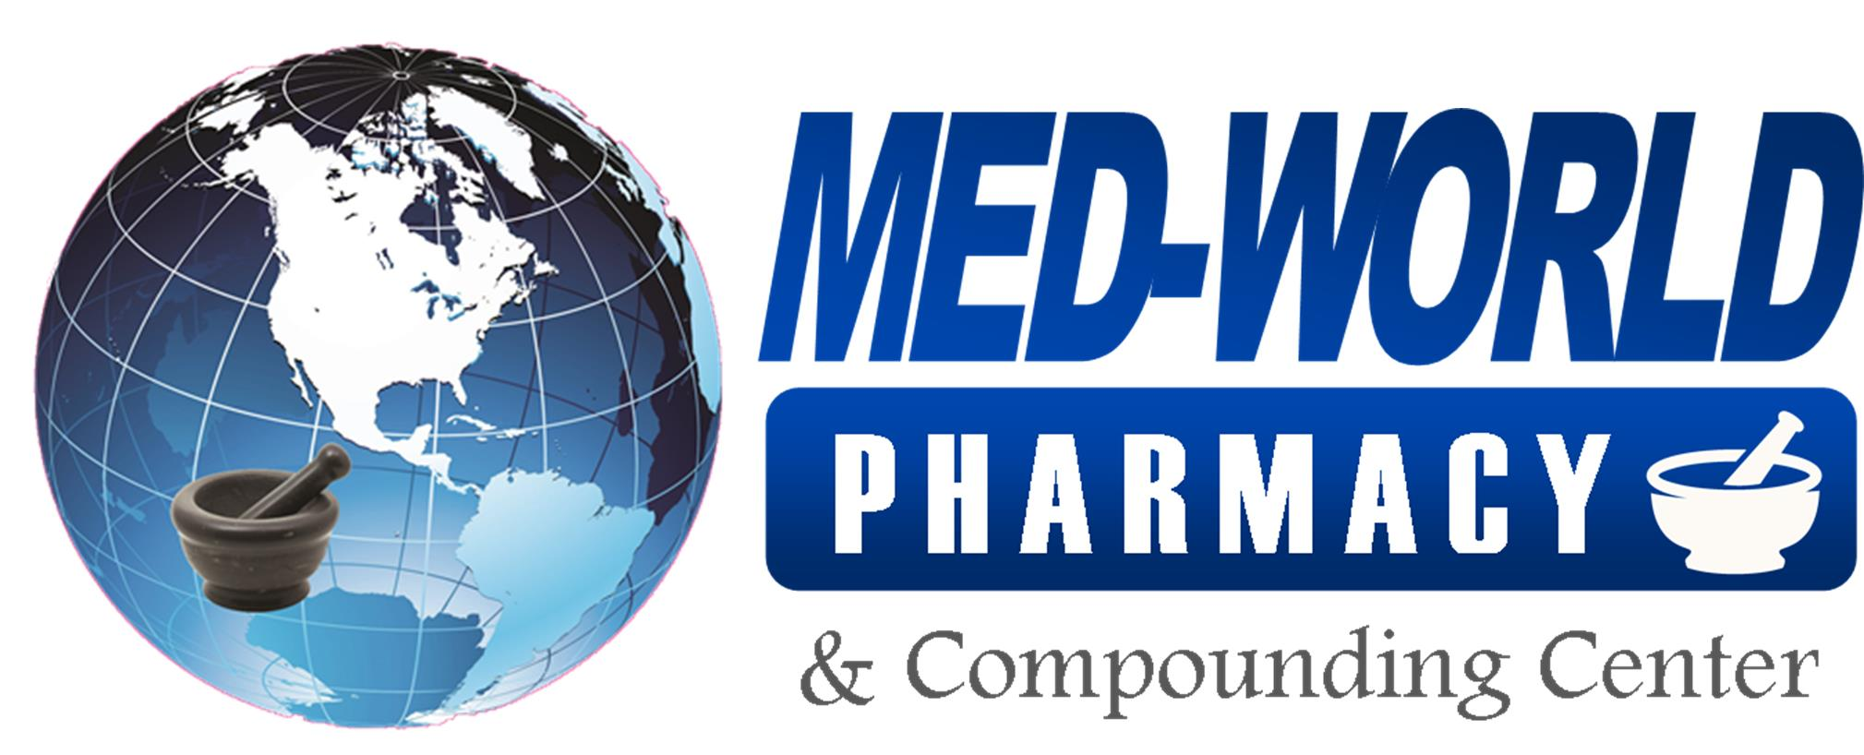

**Phase I includes:**

**April 24, 2020, Oklahoma will allow the following businesses to reopen:**

• Personal care businesses, such as hair salons, barbershops, spas, nail salons, and pet groomers

• State parks and outdoor recreation

**May 1, 2020, Oklahoma will allow the following businesses to reopen:**

• Dining, entertainment, movie theatres and sporting venues

• Gyms

• Places of worship can reopen for in-person meetings or worship if they leave every other row or pew open

• Tattoo Parlors

If you or a member in your living space go to any businesses that open after April 24th, please follow these guidelines:

1. Please continue to adhere to strict sanitation and disinfecting protocols and social distancing guidelines
   1. Pre-Screen: Employers should measure the employee’s temperature and assess symptoms prior to them starting work.
   2. Regular Monitoring: As long as the employee doesn’t have a temperature or symptoms, they should self-monitor under the supervision of their employer’s occupational health program.
   3. Wear a Mask: The employee should wear a face mask at all times while in the workplace
   4. Social Distance: The employee should maintain 6 feet and practice social distancing as work duties permit in the workplace.
   5. Disinfect and Clean work spaces: Clean and disinfect all areas such as offices, bathrooms, common areas, shared electronic equipment and hands every hour then document on the sanitation log.
2. Document on the symptom checker document on the day the travel event occurred if you or a person in your living space has gone to one of these businesses
3. The pharmacy lobby area will continue to be closed at this time. This will be re-evaluated after June 1, 2020 as this may be the time Phase 3 is implemented (subject to all guidelines being met) in Oklahoma.

The pharmacy discourages attending any business or gathering outside of essential businesses.